New Heritage Partnership to Protect Important Archive

The Centre for Computing History, a major archive, hands-on museum and learning centre in Cambridge and the LEO Computers Society, a group passionate about the promotion of the world’s first business computer (the Lyons Electronic Office - or LEO - from the 1950s), today announced a new partnership that will work to protect a wide range of heritage objects that are currently at risk.

The direct connection between the two organisations lies in the social and tech history that they both focus on. The LEO Computers Society is committed to getting these British room-sized computers of the past greater recognition as game changers in the development of computing in the UK. The LEO is already recognised in the Guinness Book of Records as the first business computer in the world but its story remains less well-known than it should be. The Centre for Computing History recognises just how important these ‘giant brains’ were and, following a successful exhibition held at the Centre in November last year, realised how much important documentation the Society has about this key moment in history. They immediately sought to make sure the archive is protected for the long term.

This important archive includes documents, photos, LEO parts and schematics and is currently scattered across people’s homes and garages. The two organisations will work together over the next few years to move the archive into suitable conditions at the Cambridge museum where it will be safe from harm and deterioration. The partners are seeking funding to do this and then to research and digitise the collection so that it can be made available to researchers and to the public for the very first time.

This major LEO archive will also enable us to support other collections of LEO material around the UK and elsewhere.

“This is a wonderful opportunity for us to make sure that the historical records of such an important period in computing history are protected for the long term. We are looking forward to being able to unlock the stories within this unique heritage archive,” said Jason Fitzpatrick, CEO of the Centre for Computing History.

“We hope this will be the start of a long and fruitful partnership between two organisations. When we met the people at the Centre for Computing History we knew this was the organisation we could trust with such an important collection and we are hugely grateful for the enthusiasm and support offered to us by the Cambridge museum,” said Peter Byford, Chair of the LEO Computers Society.

For more information about the Centre for Computing History please visit www.computinghistory.org,uk and for the Leo Computers Society www.leo-computers.org.uk/.

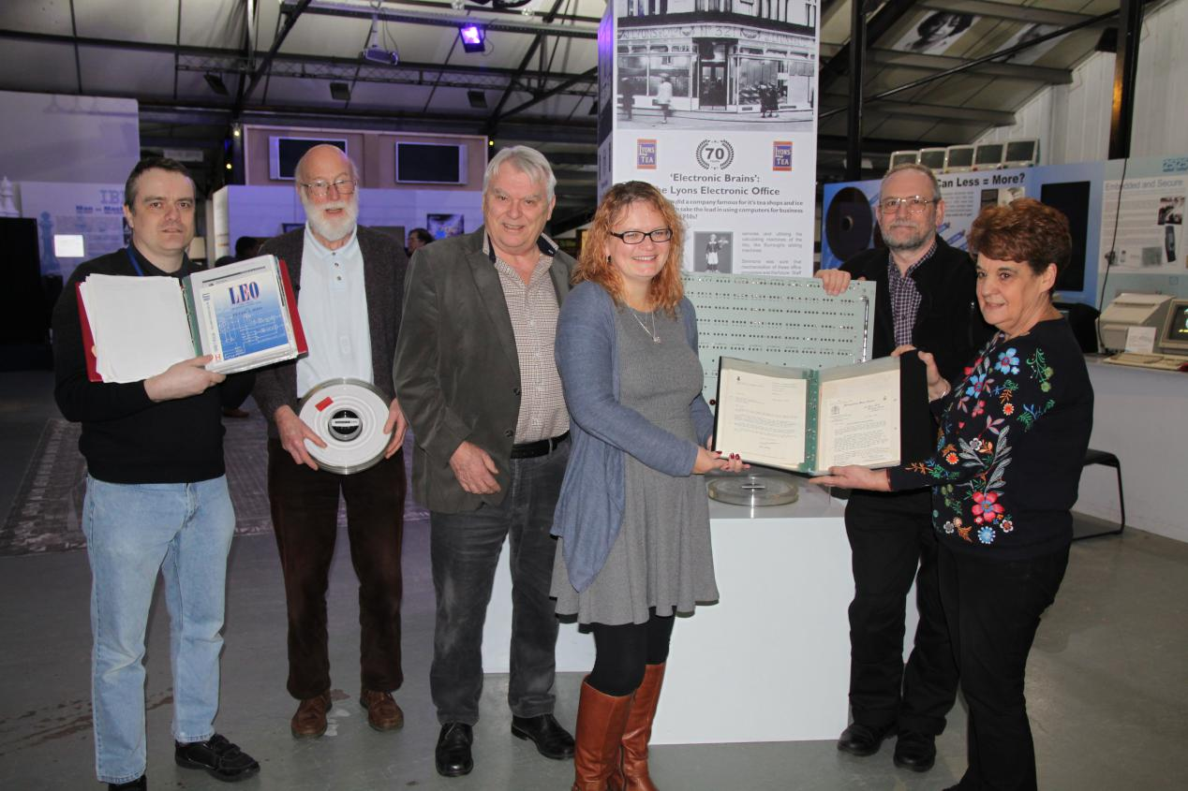
Caption: The Leo Computers Society hands important heritage documents over to the Centre for Computing History for safekeeping.

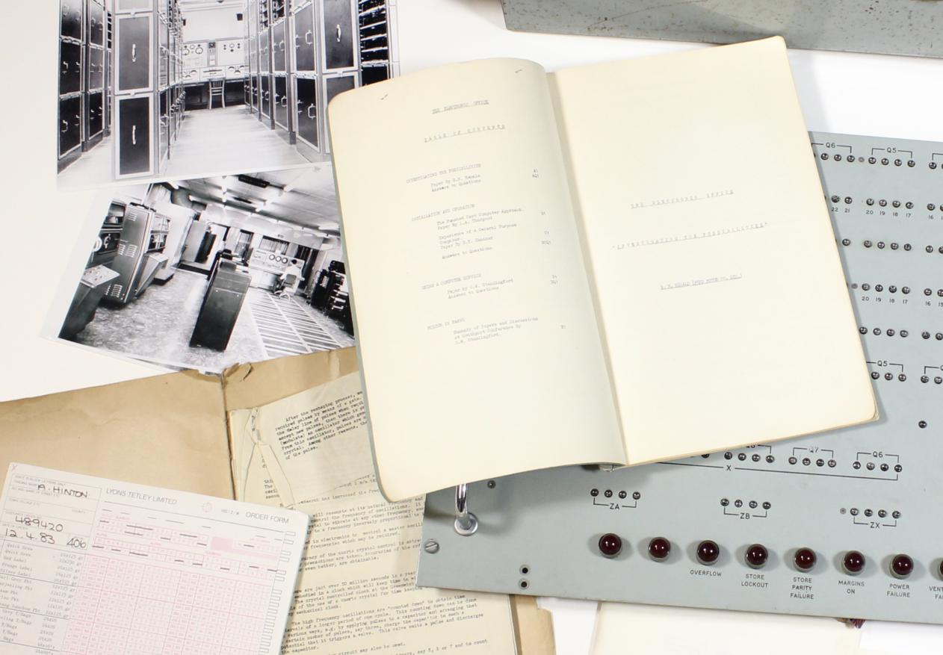 Caption: Part of the archive now held at the Centre for Computing History.

Notes to editors:
Centre for Computing History
Established in 2006, the Centre for Computing History is a charitable heritage organisation with a strong focus on learning. Since opening in Cambridge in August 2013, the Centre has helped people understand how tech has shaped the modern world and revolutionised the way we live, work and play through interactive displays and exhibitions, our schools programme, learning events and workshops, and an astonishing collection of computers old and new.

The LEO Computers Society
The Society is committed to providing communications to its members including the organising of Reunions and to promoting and protecting LEO's history. Membership of the Society is open to all ex-employees of LEO Computers and its succeeding companies, anyone who worked with a LEO computer and anyone with a specific interest in the history of LEO Computers. Membership is currently free of charge.
For further information or images, please contact:
Lisa McGerty
Email: lisa@computinghistory.org.uk
www.computinghistory.org.uk
Date : 08-02-2018

