IMAGINE THE GAME: RESEARCH ABOUT CREATIVE IMAGINATION AND THE ZX SPECTRUM

I am a professor of Film and Cultural Studies at Kingston University in London, and author of several books on popular culture. I first owned a ZX Spectrum in 1982 and wrote my first published feature for Crash magazine in 1988 – issue 51. http://www.crashonline.org.uk/51/runagain.htm

This research is for an academic article, which I will write for a scholarly journal during 2018-2019. I will be happy to use your name in the article, or you can remain anonymous if you prefer.

Please complete the questions below with as much information as you can. There is no correct answer: I want your honest opinions and your memories of playing these games.

Thank you!
Will Brooker

Your name:

Do you mind if I use your name in the article? Please delete one: YES / NO

Your age (optional):

When was your main period of playing Spectrum games? (eg. 82-88; the 1990s; from 2000 onwards; from 1982 to the present day?) Answer as fully as you want.

- This first question is very general.
The ZX Spectrum had limited graphics and colour. Do you think this encouraged players to use their imaginations more, compared to the detailed and realistic graphics of recent consoles?
Please say as much as you want, in your answer, and give examples from your own experience of using your imagination when playing Spectrum games.

- Here is a screenshot from Fantasy’s Backpacker’s Guide to the Universe.
Compare this with the cover art and the Oliver Frey cover painting from Crash magazine.

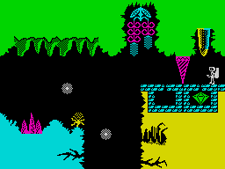

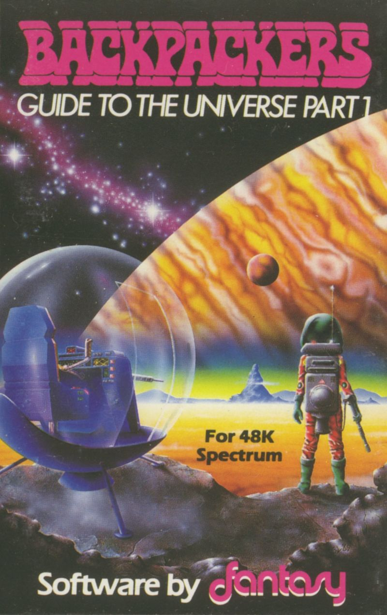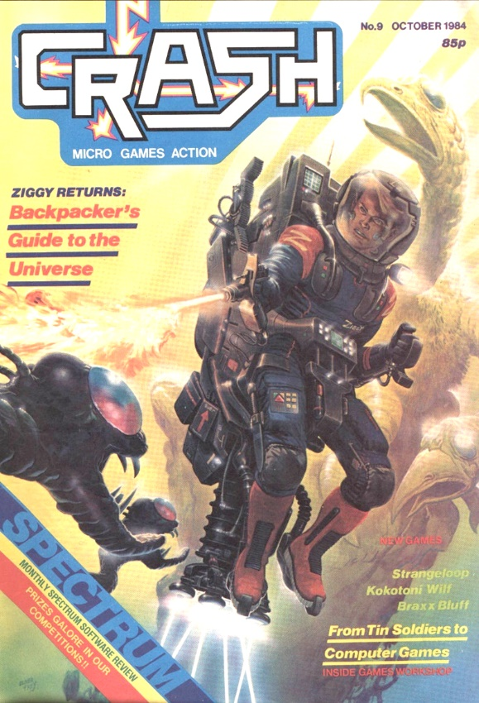

If you were playing a game like this, would the artwork, and magazine covers, help you to imagine what the character and the environment ‘really’ looked like?

- Here’s another example: Ultimate’s Jetpac.
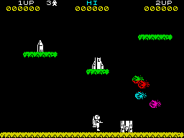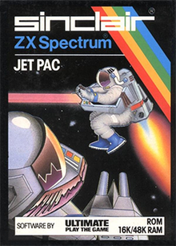

Does the cover art encourage us to see that this is what the character ‘really’ looks like? Please say as much as you like in your response, and discuss other games you remember, if you want.

- One more example: Shadowfire, by Beyond. The graphics are icons, and the cover is very detailed.

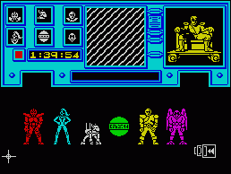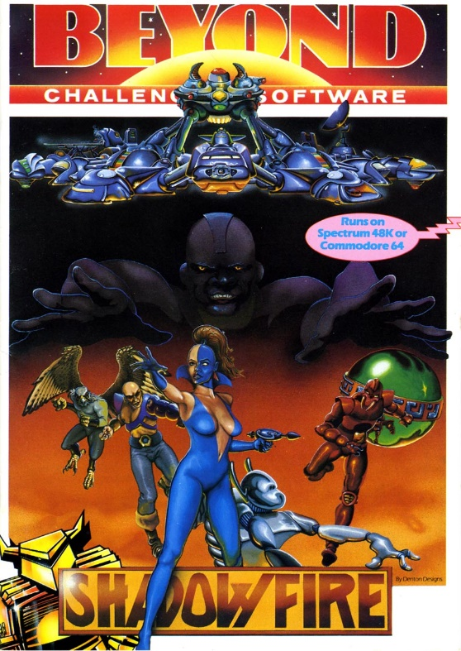

Again, does the cover art help us to imagine the character we are playing in the game, even though the graphics are limited?

- Here’s a screenshot from Avalon, by Hewson. Again, the graphics and colours are limited in what they can show us.
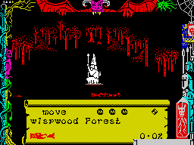
How do we know that we are looking at a forest of trees, even though there is little detail, and the background is red? Again, there is no right answer here and this is an open question!

- When playing a game like Avalon or Lords of Midnight, by Mike Singleton (shown here) did you ever feel immersed in the world of the game, even though the graphics were simple?
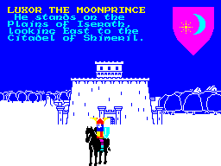
Please say as much as you can about your memories of playing these games, and how you felt immersed in them.

- Final question! These games – Avalon, Lords of Midnight and Tir Na Nog, by Gargoyle (shown below) – are all set in fantasy landscapes, like forests, caves, castles and wilderness.
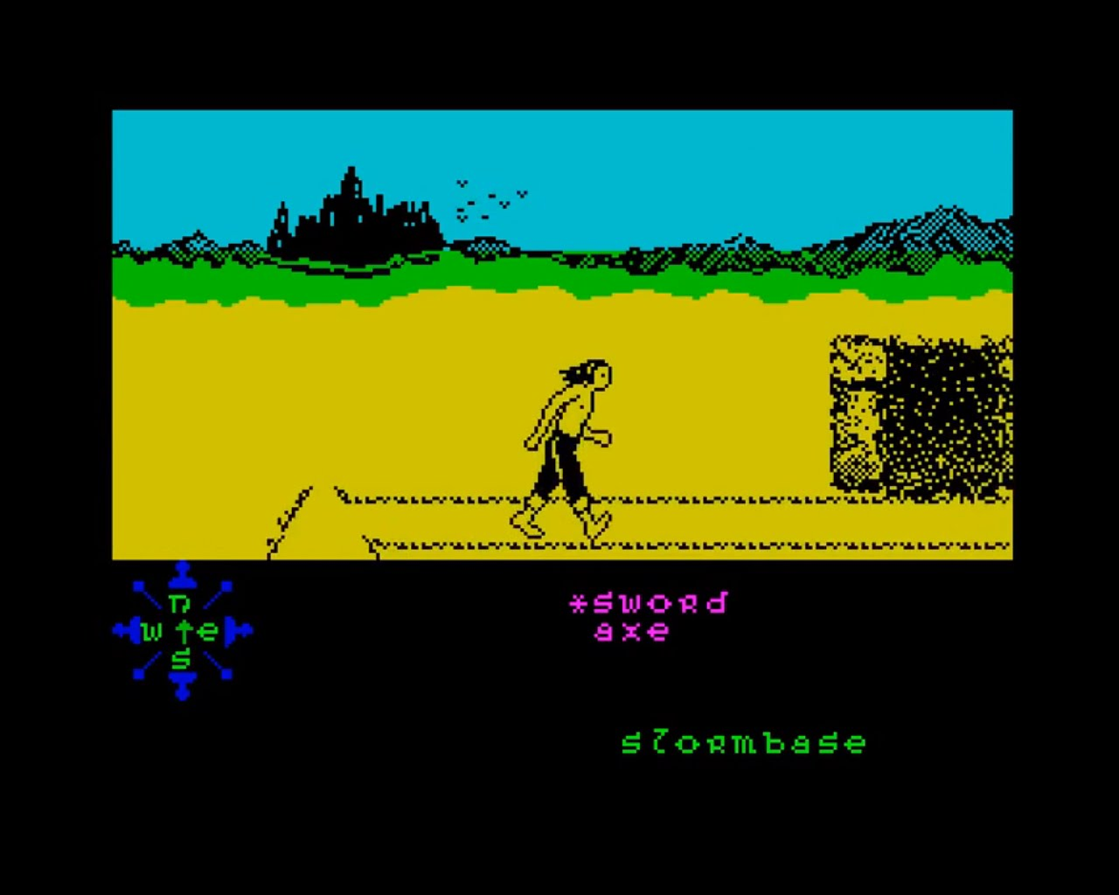

When you played those games, were you ever reminded of real places you’d been to (perhaps on holiday) or about places you’d seen on TV or in films?
Please say as much as you want, in your answer.

Thank you for taking part. Please send your answers to w.brooker@kingston.ac.uk

